**Normal Equation**

**Note:** [8:00 to 8:44 - The design matrix X (in the bottom right side of the slide) given in the example should have elements x with subscript 1 and superscripts varying from 1 to m because for all m training sets there are only 2 features *x*0 and *x*1. 12:56 - The X matrix is m by (n+1) and NOT n by n. ]

Gradient descent gives one way of minimizing *J*. Let’s discuss a second way of doing so, this time performing the minimization explicitly and without resorting to an iterative algorithm. In the "Normal Equation" method, we will minimize *J* by explicitly taking its derivatives with respect to the *θj* ’s, and setting them to zero. This allows us to find the optimum theta without iteration. The normal equation formula is given below:

*θ* = (*XTX*)−1*XTy*

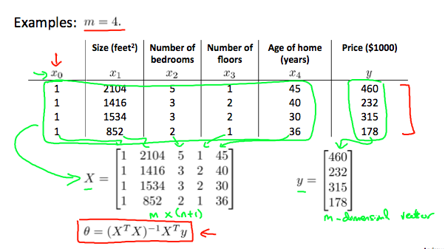

There is **no need** to do feature scaling with the normal equation.

The following is a comparison of gradient descent and the normal equation:

|  |  |
| --- | --- |
| **Gradient Descent** | **Normal Equation** |
| Need to choose alpha | No need to choose alpha |
| Needs many iterations | No need to iterate |
| O (*kn*2) | O(*n*3), need to calculate inverse of *XTX* |
| Works well when n is large | Slow if n is very large |

With the normal equation, computing the inversion has complexity O(*n*3). So if we have a very large number of features, the normal equation will be slow. In practice, when n exceeds 10,000 it might be a good time to go from a normal solution to an iterative process.